SPH3U0 **Kinematics Unit: Graph Analysis Package I for Uniform Motion**

**1A) Uniform Motion: Position-Time Graphs**

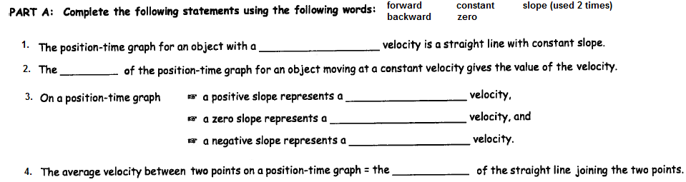

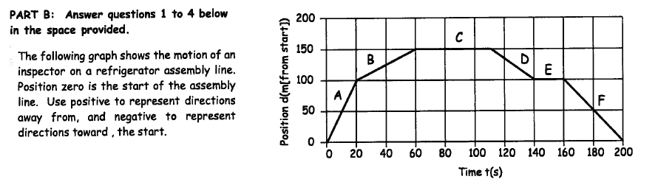

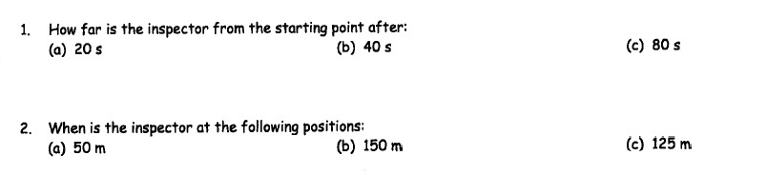

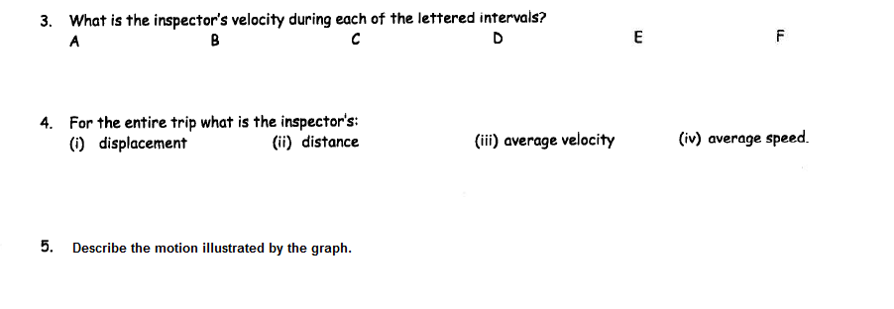

**1B) Position-Time Graphs for Uniform Motion**

For constant velocity, a position-time graph appears as a ________________________. To find the corresponding velocity, you calculate the ______________ of the graph.

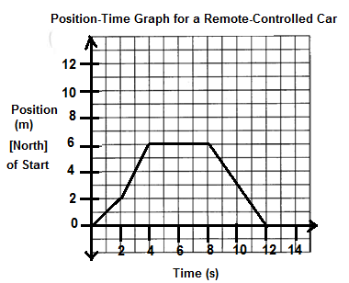For each position-time graph below, calculate the velocity of each segment and describe the motion. Draw the corresponding velocity-time graph on the grid provided.

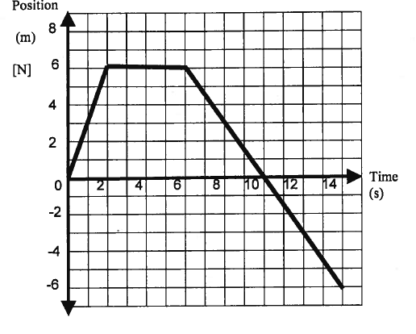

a) b)

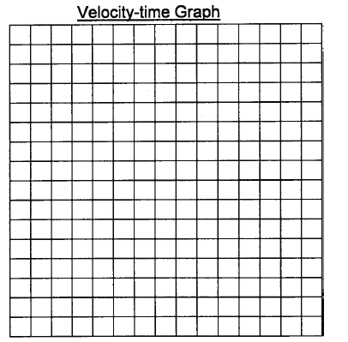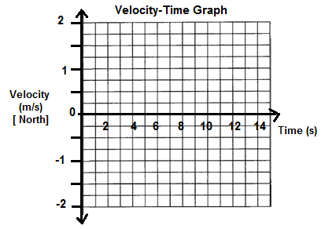

**Calculations**

**Graph Description:**

**●0-2 s:**

**●2-6 s:**

**●6-14 s:**

**What happened at 10 seconds?**

**Calculations**

**Graph Description:**

**●0-2 s:**

**●2-4 s:**

**●4-8 s:**

c) **Motion of a Train Pulling into a Station to Pick Up Passengers**

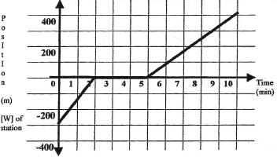

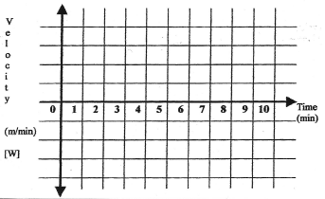

a) Draw the corresponding velocity-time graph. Show your calculations here.

b) Describe the motion of the train in each interval.

c) What is the initial position of the train? _____________________________________

What is the final position of the train? ______________________________________

What is the overall displacement of the train?_________________________________

What is the average velocity of the train over the full interval shown? ______________________________

**2) Velocity-Time Graphs for Uniform Motion**

**A. Complete the following statements using the words below:**

***y-intercept horizontal area under the curve add forward backward***

1. The velocity-time graph for constant velocity is a straight _____________ line.

2. The velocity magnitude and direction is indicated by the ____________________ of the line.

3. A line in the positive quadrant indicates _________________ motion.

4. A line in the negative quadrant indicates _________________ motion.

5. The find the displacement of the object, you calculate the ____________________ for the given time interval.

6. To find total or resultant displacement, you must _________ up the individual displacements.

B**) For each of the following velocity time graphs:**

**i: Describe the motion. ii. Calculate the displacement over each interval.**

**iii. Add up the displacements and graph the position-time graph ASSUMING EACH OBJECT STARTS AT THE ORIGIN**.

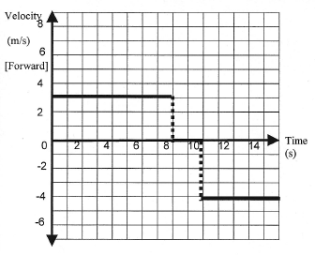 **Velocity vs. Time Graph #1 Velocity vs Time Graph #2** -Motion of

Toy Train Moving Back and Forth on a Straight Track

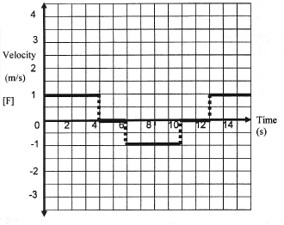

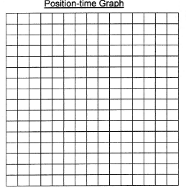

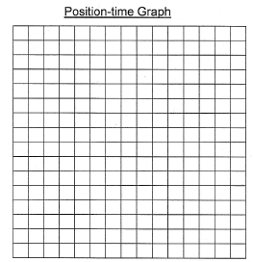

**Description of Motion:**

Interval 1: 2: 3: 4: 5:

**Calculations** Position vs.Tme Chart

|  |  |
| --- | --- |
| Time (s) | Position (m) [F] |
| 0.0 | 0.0 |
|  |  |
|  |  |
|  |  |
|  |  |
|  |  |

**Description of Motion:**

Interval 1: Interval 2: Interval 3:

**Calculations** Position vs.Tme Chart

|  |  |
| --- | --- |
| Time (s) | Position (m) [F] |
| 0.0 | 0.0 |
|  |  |
|  |  |
|  |  |